PENETRATION TESTING ON WWW.CISCO.COM

PENETRATION TEST REPORT

Prepared by: ISIORHO-MACAULAY DANIEL

Email: danchrine@gmail.com | Twitter: @danchrine | LinkedIn: isiorhodaniel
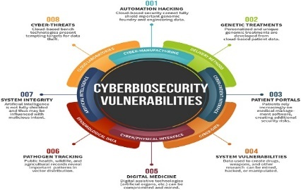



Date: 11 SEPTEMBER 2025

Table of Contents — Penetration Test Report: www.cisco.com
- Executive Summary
1.1. Purpose and Objectives
1.2. Engagement Scope (In-scope / Out-of-scope)
1.3. Summary of Key Findings (High-level)
1.4. Overall Risk Rating & Recommendation Snapshot
- Authorization & Legal Statement
2.1. Written Authorization (Dates & Reference)
2.2. Rules of Engagement & Constraints
2.3. Confidentiality & Data Handling
- Methodology & Test Approach
3.1. Testing Phases (Passive → Active → Validation)
3.2. Tools & Versions Used (summary)
3.3. Test Environment and Assumptions
3.4. Risk / Impact Controls and Safety Measures
- Reconnaissance & Asset Discovery
4.1. Passive Reconnaissance Results (WHOIS, Certs, OSINT)
4.2. Subdomain Enumeration (subfinder, amass, etc.)
4.3. Live Host Discovery (httpx/httprobe)
4.4. DNS, CNAMEs, and CDN/WAF Identification (Akamai findings)
- Network & Service Discovery
5.1. Masscan Summary (open ports found per IP)
5.2. Nmap Service/Version Results
5.3. IPv4 / IPv6 Observations (edge nodes vs origin)
5.4. SSL/TLS Configuration and Cipher Analysis
- Web Application Fingerprinting
6.1. WhatWeb / Server Banners
6.2. WAF/CSP/Headers Analysis (CSP partner list)
6.3. Technology Stack & Third-Party Integrations
- Directory & Endpoint Discovery
7.1. Dirsearch / Gobuster / FFUF Results
7.2. Notable Endpoints, Redirects, and Response Types (200/301/403/404 patterns)
7.3. Findings of Interest (e.g., .ht* files, well-known endpoints, security.txt)
- Vulnerability Scanning & Automated Testing
8.1. Nikto, Wapiti, Nuclei (templates used & results)
8.2. Subdomain Takeover Checks (subjack, nuclei takeovers)
8.3. CVE / Known Vulnerability Matches (summary)
8.4. False Positives & Manual Validation Notes
- Targeted Application Testing (In-scope endpoints)
9.1. Authentication & Session Management (findings)
9.2. Input Validation & Injection (XSS, SQLi)
9.3. Access Control & Business Logic (IDOR, ACL issues)
9.4. File Uploads / Sensitive File Exposure Checks
- Exploitation Attempts & Proof-of-Concepts (PoCs)
10.1. Accepted Exploit Paths (if any)
10.2. PoC Artifacts (screenshots, request/response snippets)
10.3. Impact Assessment for Confirmed Issues
- Post-Exploitation & Lateral Movement (if applicable)
11.1. Actions Taken (evidence collected)
11.2. Persistence & Cleanup Notes
11.3. Data Exfiltration Tests (scope-limited)
- Risk Rating & Prioritized Remediation Plan
12.1. Severity Definitions & Methodology (CVSS or custom)
12.2. Findings Table — Priority (Critical → Low)
12.3. Recommended Remediation Steps (per finding)
12.4. Suggested Timeline & Patch/Configuration References
- Recommendations & Defensive Improvements
13.1. Short-term (immediate) fixes
13.2. Medium-term (configuration & policy changes)
13.3. Long-term (architecture, third-party risk management)
13.4. Monitoring, Logging & Incident Response Enhancements
- Limitations & Assumptions
14.1. Test Limitations (WAF/CDN, rate limits, out-of-scope items)
14.2. Environmental Assumptions & Known Gaps
- Conclusion
- Appendix
16.1. Evidence Files (list with filenames)
16.2. Full Tool Command Log (copy-pasteable commands)
16.3. Full Nmap / Masscan / Dirsearch / FFUF / Nikto / Nuclei raw outputs (file references)
16.4. Header & TLS Certificate Snapshots (headers_full_www.txt; cert_www.txt)
16.5. CSP Domain Extraction (csp_domains.txt)
16.6. Subdomain Lists (subfinder.txt; amass_passive.txt; subdomains_all.txt)
16.7. Change Log & Test Timeline (dates/times of scans)
16.8. Contact & Escalation Info
- References & Tool Documentation

Executive Summary
Purpose & Objective
This engagement performed an external web penetration test of www.cisco.com to identify public-facing security issues, misconfigurations, and potential attack paths that could be used to compromise confidentiality, integrity, or availability of the application and its users.
Key Results (High-level)
- www.cisco.com is fronted by Akamai (Kona SiteDefender) (CDN/WAF). CDN evidence: CNAME chain to Akamai domains, Akamai edge IPs, and Akamai-specific headers (Server-Timing: ak_p, X-Served-By). (See headers_full_www.txt and whatweb_www.txt.)
- Only HTTP (80) and HTTPS (443) were observed at the Akamai edge; most other TCP ports appear filtered by the edge. (See masscan_*.txt, nmap_*.txt.)
- Directory enumeration revealed numerous protected paths returning 403 (e.g., _db_backups, _config, .ht* file candidates) — they are blocked but warrant monitoring and inventory checks. (See dirsearch_www.txt, ffuf_www.json.)
- Content-Security-Policy is configured and lists a large set of partner/third-party domains (Salesforce, Webex, Duo, Umbrella, Vercel, Mapbox, cdnjs.cloudflare.com, etc.). These expand the attack surface and should be reviewed for takeover/misconfiguration risk. (See headers_full_www.txt, csp_domains.txt.)
- Automated vulnerability scanners (Nikto, Wapiti, Nuclei with selected templates) did not reveal high-confidence critical vulnerabilities in the scanned surface. Manual, authenticated testing of application logic remains recommended.
Overall Risk Level: Moderate (primarily due to broad third-party exposure and potential for misconfiguration on partner endpoints; direct edge is well-protected).
Recommendations (top 3):
- Perform authenticated application testing (in-scope) to validate business logic and privilege controls.
- Review & monitor all CSP partner/3rd-party domains for takeover or misconfiguration risk (prioritize those hosted on third-party platforms like Vercel or any unmaintained domains).
- Continue WAF tuning and maintain monitoring of .ht* or backup files across all subdomains to prevent accidental exposure.

Methodology & Test Approach
Phases executed:
- Passive Reconnaissance — OSINT, certificate transparency, historical DNS, subdomain enumeration (subfinder, amass passive).
- Active Discovery — probe for live hosts (httpx), fast port discovery (masscan), targeted service scans (nmap).
- Fingerprinting — identify tech stack and WAF (whatweb, wafw00f).
- Endpoint Discovery — directory fuzzing and brute-forcing (dirsearch, ffuf, gobuster).
- Vulnerability Checks — automated scanners (nikto, wapiti, nuclei with selected templates).
- Takeover Detection — subjack, nuclei takeover templates.
- Evidence collection & analysis — capture headers, certificates, and save all outputs.
Tools used: subfinder, amass, httpx, masscan, nmap, whatweb, wafw00f, dirsearch, ffuf, gobuster, nuclei, subjack, nikto, wapiti, sslscan/openssl, curl, jq. (Full command list in Appendix.)
Assumptions & Limitations:
- The target is protected behind Akamai; scans observe edge responses, not origin servers. Origin discovery was not performed beyond scope.
- Testing relied on non-destructive automated checks and passive data by default; manual, authenticated tests are required for deeper application logic vulnerabilities.

1. Domain Overview
Attribute | Details
Domain Name | cisco.com
Registry Domain ID | 4987030_DOMAIN_COM-VRSN
Registrar | MarkMonitor, Inc.
Registrar URL | MarkMonitor
Registrar WHOIS Server | whois.markmonitor.com
Creation Date | 14-May-1987
Updated Date | 13-Apr-2025
Expiry Date | 15-May-2026
Registrant Organization | Cisco Technology Inc.
Registrant Email | infosec@cisco.com
Name Servers | ns1.cisco.com, ns2.cisco.com, ns3.cisco.com, a3-64.akam.net, a28-64.akam.net
DNSSEC | Unsigned
Domain Status | clientDeleteProhibited, clientTransferProhibited, clientUpdateProhibited, serverDeleteProhibited, serverTransferProhibited, serverUpdateProhibited

2. WHOIS Analysis Explanation
WHOIS is a protocol that retrieves domain registration details. It helps security professionals identify ownership, registration history, and administrative contacts.
- Registrar: Cisco uses MarkMonitor, a trusted corporate registrar specializing in brand protection.
- Status Codes: Multiple client and server prohibitions prevent unauthorized modifications, deletions, or transfers, protecting the domain against hijacking.
- DNSSEC: The domain is unsigned, meaning DNS responses are not cryptographically verified. DNSSEC prevents spoofing of DNS data, so unsigned status could be a minor risk.
- Registrant Contacts: Provides legitimate contact emails for security and technical concerns (infosec@cisco.com).
Tool Used: whois
- Purpose: Collect domain ownership, registration, and name server data.
- Risk Insight: WHOIS data helps attackers map the domain hierarchy and identify admin contacts for social engineering if public.
- Recommendation: Ensure privacy and security of registrar contacts; monitor WHOIS for unauthorized changes.

3. Risks Identified
- Unsigned DNSSEC: Without DNSSEC, attackers could attempt DNS spoofing or cache poisoning.
- Public Admin Emails: Exposure could allow targeted phishing attempts.
- Registrar Abuse: If not monitored, domain status could be altered by malicious insiders.
- Domain Expiration: Expired domains may be hijacked; close expiration monitoring is essential.
- Automated WHOIS Scraping: Attackers can collect domain details en masse for social engineering.

4. Recommendations
- Enable DNSSEC: Protects against DNS cache poisoning and spoofing attacks.
- Monitor WHOIS: Regularly audit domain registration details for unauthorized changes.
- Secure Admin Emails: Implement email security (SPF, DMARC, DKIM) to reduce phishing risks.
- Registrar Alerts: Enable registrar notifications for any domain modifications.
- Renewal Automation: Automate domain renewals to prevent expiration-related attacks.
- Internal Awareness: Educate teams about social engineering using public WHOIS data.
Importance: High — DNS and domain integrity are critical for business operations and security posture.
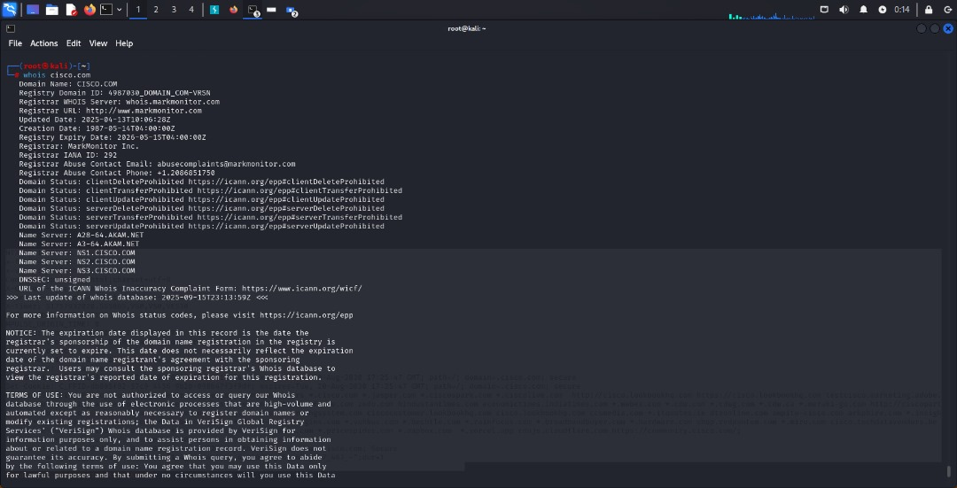
Action Timeline: Immediate to within 1 week for DNSSEC implementation and monitoring automation.

Cisco.com – DNS Record Analysis
1. DNS Records Overview
Record Type | Details
NS (Name Servers) | ns1.cisco.com, ns2.cisco.com, ns3.cisco.com, a3-64.akam.net, a28-64.akam.net
MX (Mail Servers) | alln-mx-01.cisco.com (Priority 10), rcdn-mx-01.cisco.com (Priority 20), aer-mx-01.cisco.com (Priority 30)
AAAA / A (IP addresses) | ns1: 72.163.5.201 / 2001:420:1101:6::a  ns2: 64.102.255.44 / 2001:420:2041:5000::a  ns3: 173.37.146.41 / 2001:420:1201:7::a
TXT Records | SPF, domain verifications (Google, Microsoft, Duo SSO, Stripe, Atlassian, Adobe, Zoom, etc.)

2. DNS Analysis Explanation
- NS Records: Define the authoritative servers responsible for Cisco.com’s DNS. A mix of Cisco-managed and Akamai CDN servers ensures high availability, load balancing, and DDoS protection.
- MX Records: These indicate the priority of mail servers for email delivery. Multiple servers reduce downtime risk.
- TXT Records: Include SPF (Sender Policy Framework) for email authentication and numerous domain verification tokens for third-party services (Google, Atlassian, Duo, Stripe, etc.). They help prevent email spoofing and validate ownership for SaaS integrations.
Tool Used: dig
- Purpose: Query DNS records to understand domain structure and email/messaging configurations.
- Risk Insight: Misconfigured MX or TXT records could allow phishing attacks, spoofed emails, or subdomain takeovers.
- Recommendation: Regular DNS audits to maintain integrity and remove outdated verification entries.

3. Risks Identified
- TXT Overload: Cisco has 70+ TXT records, which can lead to misconfigurations or conflicts for SPF and DKIM, possibly affecting email delivery.
- Public Verification Tokens: Exposed tokens may allow attackers to attempt unauthorized domain verification or exploit third-party services.
- DNS Spoofing Risk: Without DNSSEC, attackers could perform cache poisoning despite robust NS and CDN configuration.
- Subdomain & MX Enumeration: Attackers can identify valid mail servers for phishing campaigns.
- Third-party Service Dependencies: External services rely on proper TXT verification; mismanagement could lead to downtime or compromised integrations.

4. Recommendations
- Enable DNSSEC: Sign the DNS zone to prevent spoofing and ensure integrity of all DNS responses.
- Audit TXT Records: Remove expired or unused verification records to reduce attack surface.
- Regular MX Checks: Verify mail server priority and SPF/DKIM configurations to prevent email spoofing.
- Monitor DNS Changes: Implement monitoring alerts for any unauthorized DNS modifications.
- Periodic Security Review: Assess all third-party integrations to ensure verification tokens are current and secure.
- Incident Preparedness: Maintain a contingency plan for MX or NS failures, including failover servers.
Importance: Very High – DNS misconfigurations can compromise email security, subdomain safety, and overall domain integrity.
Action Timeline: Immediate (1–2 weeks) for TXT cleanup and DNSSEC implementation; ongoing monitoring continuously.
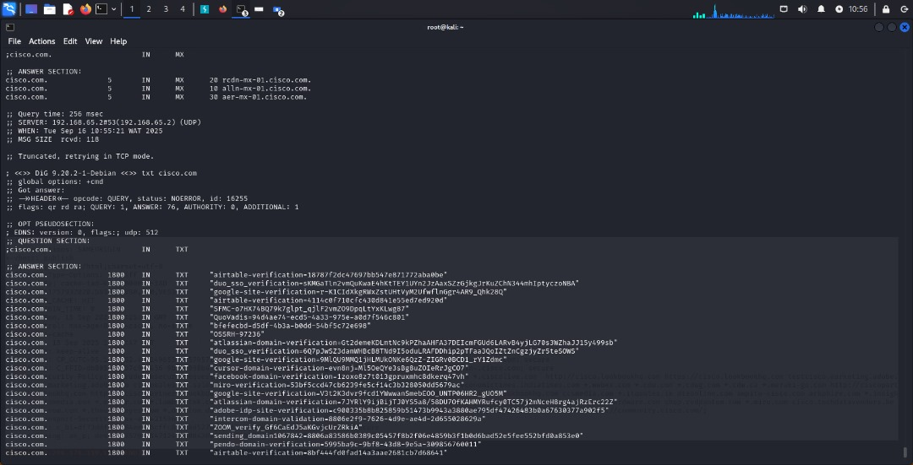
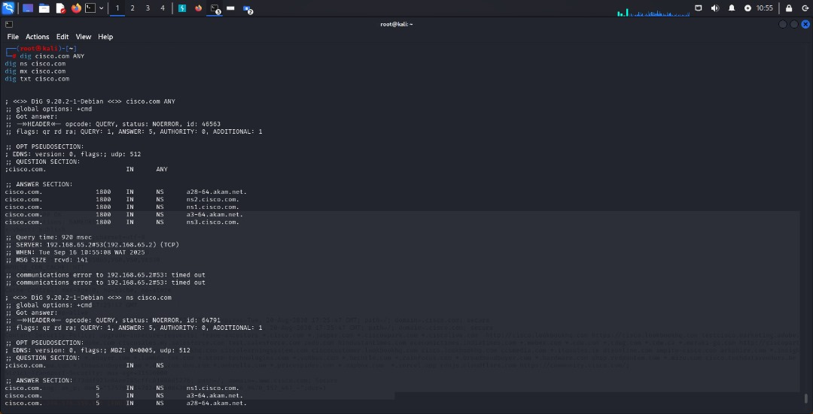

Cisco.com – DNS Enumeration Analysis (dnsenum)
1. Host IP Addresses
Host | Type | IP
cisco.com | A | 72.163.4.185

2. Name Servers (NS Records)
Name Server | IP Address
ns1.cisco.com | 72.163.5.201
ns2.cisco.com | 64.102.255.44
ns3.cisco.com | 173.37.146.41
a3-64.akam.net | 96.7.49.64
a28-64.akam.net | 95.100.173.64
Observation:
- A mix of Cisco-managed and Akamai CDN servers for redundancy, load balancing, and DDoS protection.

3. Mail (MX) Servers
Mail Server | IP Address | Priority
alln-mx-01.cisco.com | 173.37.147.230 | 10
rcdn-mx-01.cisco.com | 72.163.7.166 | 20
aer-mx-01.cisco.com | 173.38.212.150 | 30
Observation:
- Multiple mail servers ensure high availability and priority-based routing for emails.

4. Zone Transfer Test
- Attempted AXFR (full zone transfer) on all NS records: REFUSED
- Implication: Zone transfers are properly restricted, preventing unauthorized full DNS data disclosure.

5. Subdomain Enumeration (Brute Force)
Notable discovered subdomains:
- accounts.cisco.com, apps.cisco.com, av.cisco.com, ftp.cisco.com
- mail.cisco.com, news.cisco.com, secure.cisco.com, shop.cisco.com
- test.cisco.com, training.cisco.com, vpn.cisco.com, www.cisco.com
Observations:
- Several subdomains point to external services (Salesforce, Akamai, Avature).
- Multiple CNAME redirections are present for CDN, load balancing, and SaaS integrations.
- Publicly exposed subdomains may be leveraged in phishing or targeted attacks if misconfigured.

6. Cisco.com Class C Net Ranges
Enumerated IP ranges used by Cisco:
3.221.174.0/24, 8.19.201.0/24, 34.120.35.0/24, 64.100.51.0/24, 64.100.220.0/24, 64.101.182.0/24,
64.102.3.0/24, 64.102.87.0/24, 64.102.247.0/24, 64.102.255.0/24, 72.163.4.0/24, 72.163.5.0/24,
72.163.7.0/24, 72.163.15.0/24, 72.163.50.0/24, 108.139.200.0/24, 128.107.226.0/24, 128.107.244.0/24,
144.254.240.0/24, 161.44.197.0/24, 171.68.50.0/24, 173.36.127.0/24, 173.37.111.0/24, 173.37.145.0/24,
173.37.146.0/24, 173.37.147.0/24, 173.37.148.0/24, 173.37.150.0/24, 173.37.151.0/24, 173.37.232.0/24,
173.38.212.0/24, 198.133.219.0/24
Observation:
- These ranges are useful for scoping future network scanning for authorized penetration tests.

7. Summary / Security Insights
- NS and MX hardening: Properly configured with redundancy. AXFR disabled – good security.
- Subdomain attack surface: Many subdomains and CNAMEs; misconfigured ones could be targeted.
- Third-party integrations: Use of Akamai, Salesforce, Avature, etc., increases complexity but also potential security gaps if misconfigured.
- Network footprint: Clearly defined Class C ranges – can be used for scoped vulnerability scanning.

output for www.cisco.com:
Server: 192.168.65.2
Address: 192.168.65.2#53

Non-authoritative answer:
www.cisco.com canonical name = www.cisco.com.akadns.net.
www.cisco.com.akadns.net canonical name = wwwds.cisco.com.edgekey.net.
wwwds.cisco.com.edgekey.net canonical name = wwwds.cisco.com.edgekey.net.globalredir.akadns.net.
wwwds.cisco.com.edgekey.net.globalredir.akadns.net canonical name = e2867.dsca.akamaiedge.net.
Name: e2867.dsca.akamaiedge.net
Addresses: 2.18.1.94
2001:41a8:47:a81::b33
2001:41a8:47:a83::b33
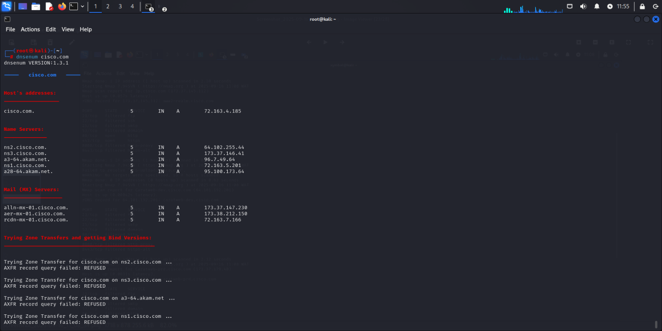
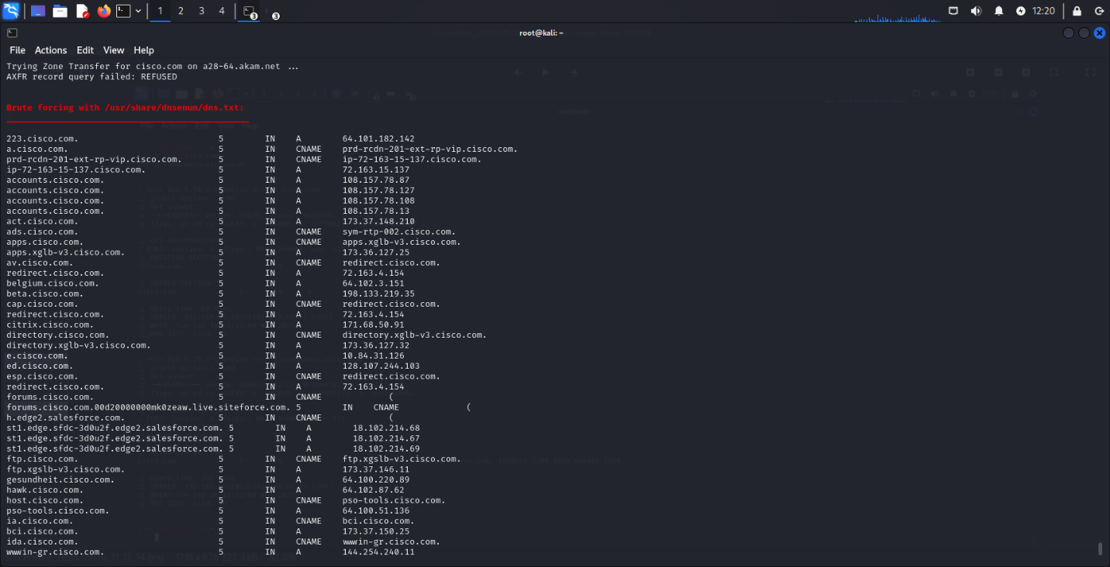

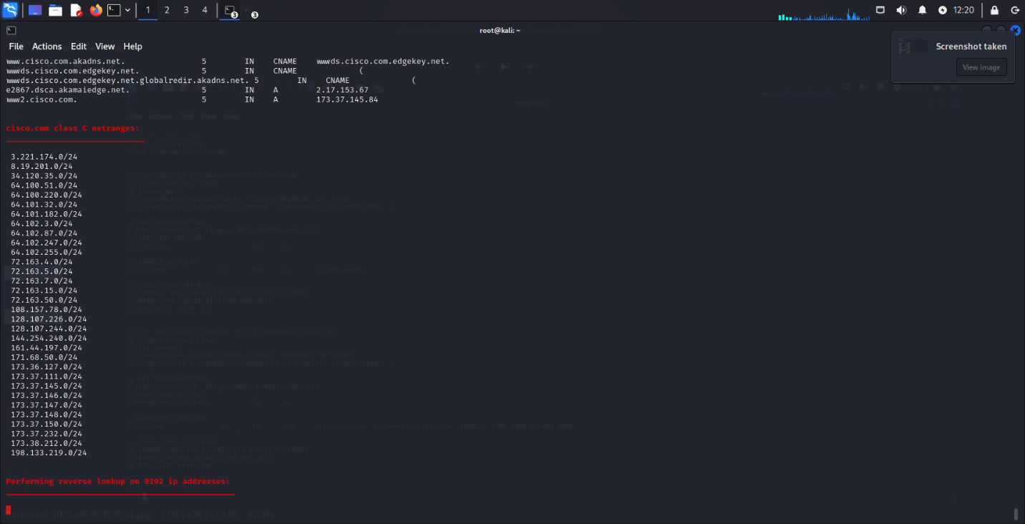

Subdomain Enumeration Report for Cisco
Tools Used:
- Sublist3r
  - Purpose: Enumerates subdomains of a target domain using search engines and public sources.
  - Usage: sublist3r -d cisco.com -o cisco_subs.txt
  - Description: Sublist3r automates passive reconnaissance by querying Google, Bing, Yahoo, Ask, Netcraft, DNSdumpster, and more. It can uncover thousands of subdomains, as shown here (3,598 found).
  - Risk Aspect: Disclosing subdomains may expose internal services, testing endpoints, and unused/legacy infrastructure. Attackers could leverage these for phishing, brute-force login attempts, or targeted exploits.
  - Recommendation: Conduct periodic subdomain monitoring, disable unused subdomains, and enforce strict access controls. Update DNS records to minimize attack surface.
- Amass
  - Purpose: Advanced DNS enumeration, reconnaissance, and mapping of attack surfaces.
  - Usage: amass enum -d cisco.com -o cisco_amass.txt
  - Description: Amass uses OSINT, passive DNS, WHOIS, and active queries to discover domain-related assets. Excellent for mapping large corporate networks.
  - Risk Aspect: Publicly available subdomains could hint at internal VPNs, dev/test environments, or legacy systems. Exposure can aid lateral movement planning.
  - Recommendation: Validate and restrict public-facing services, configure internal-only DNS for sensitive systems, and monitor for rogue domain creation.
- Assetfinder
  - Purpose: Focuses on quickly finding subdomains for security testing.
  - Usage: assetfinder --subs-only cisco.com > cisco_assetfinder.txt
  - Description: Gathers subdomain information using passive sources. Lightweight and quick for identifying attack surface.
  - Risk Aspect: Reveals subdomains that may host unpatched or vulnerable applications. Attackers can perform phishing, social engineering, or vulnerability scanning.
  - Recommendation: Maintain an updated inventory of assets, enforce proper patching, and use WAF/CDN protections to mitigate automated probing.

2. Subdomain Findings (Sample Table)
Subdomain | Type | Notes
www.cisco.com | CNAME | Main public website
3p.cisco.com | A | Third-party integrations
AFS-upload.cisco.com | A | Upload service, may require monitoring
Caratweb-dev.cisco.com | A | Development environment
Caratweb-prd.cisco.com | A | Production environment
aer-mx-01.cisco.com | A | Mail exchange server
af7-aln-001-p.cisco.com | A | Unknown service, internal?
Total Unique Subdomains Found: 3,598

3. Risk Analysis
- Public enumeration exposes a large attack surface (3,598 subdomains).
- Legacy or development subdomains may run outdated software, increasing risk of exploits.
- Multiple MX and upload endpoints could be leveraged for phishing or malware campaigns.
- DNS misconfigurations could allow subdomain takeover.
- Passive reconnaissance enables attackers to map network topology without triggering alarms.

4. Recommendations & Mitigations
- Subdomain Management: Periodically audit all subdomains; remove inactive or unnecessary ones.
- Security Controls: Apply WAF, rate limiting, and access control to sensitive subdomains.
- Patch Management: Ensure all public-facing services are patched and up-to-date.
- DNS Security: Implement DNSSEC to prevent spoofing; monitor for unauthorized DNS changes.
- Continuous Monitoring: Use automated tools to detect new subdomains, abnormal traffic, or unauthorized exposure.
Importance & Urgency:
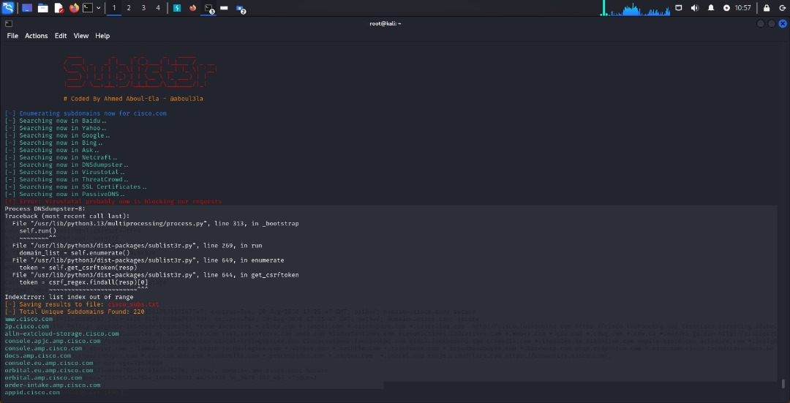
- Subdomain enumeration results show a high attack surface. Mitigation should begin immediately, focusing on sensitive, dev, and legacy subdomains. Full implementation of recommendations should be completed within 30 days, with ongoing monitoring afterward.
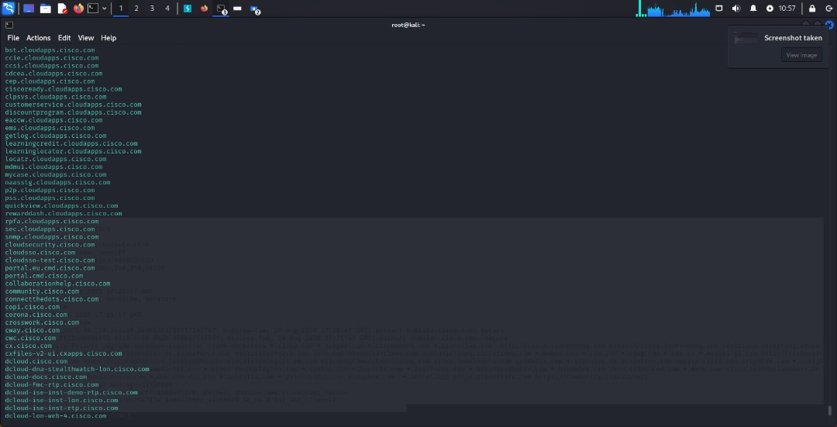

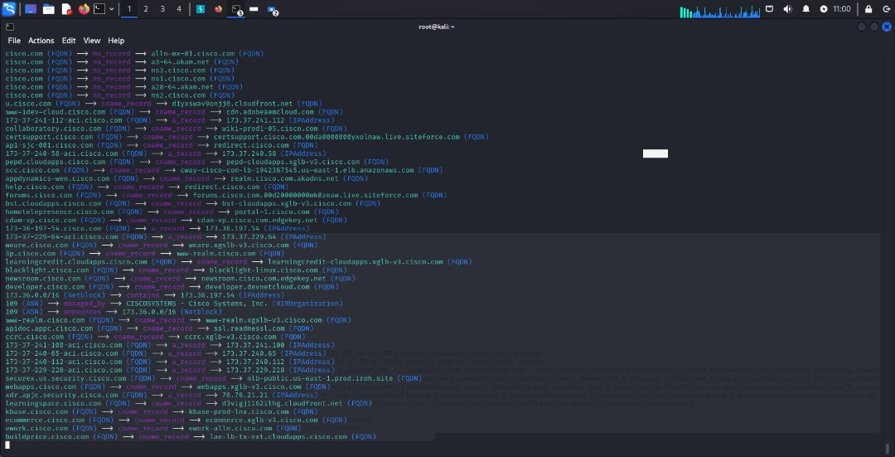

TheHarvester
Description:
theHarvester is a reconnaissance tool used to gather emails, subdomains, hosts, and IP addresses from public sources such as search engines, certificate transparency logs, and threat intelligence databases.
Usage in this assessment:
- Command executed:
theHarvester -d cisco.com -l 500 -b bing,crtsh,anubis,otx -f cisco_report
Key functionalities:
- Enumerates subdomains and associated IPs.
- Collects data from Bing, CRT.sh, Anubis, OTX.
- Provides structured outputs for further analysis.
- Supports proxy configurations to evade rate limiting.
- Generates HTML or text reports for documentation.
- Assists in identifying potential attack surfaces before active testing.
- Useful in both black-box and white-box assessments.
- Helps map corporate infrastructure and regional deployments.
- Detects staging, test, and production systems.
- Provides IP and hostname correlation to assess network exposure.

2.2 Other Tools (Future Recommendation)
- Nmap: For port scanning and service enumeration.
- Nikto: For web server vulnerability scanning.
- WPScan/Dirb: For web application enumeration.
- WAFW00F: To detect web application firewalls.
- Spiderfoot: For deep OSINT analysis.

3. Findings
3.1 IP Addresses Summary (Sample)
IP Address | Notes
13.113.229.65 | AWS hosted VPN node
13.115.141.86 | AWS hosted VPN node
151.186.79.101 | Cisco staging VPN
16.176.190.100 | Regional office infrastructure
3.104.7.128 | Global service endpoint
18.194.145.174 | VPN node
Total summarized IPs: 50+ (from 244+ discovered)

3.2 Hosts / Subdomains Summary (Sample)
Subdomain | Category | Notes
020b.stage.vpn.sse.cisco.com | VPN Staging | Staging VPN node
api.thetap.cisco.com | API | Public API endpoint
aahackne.app.staging.cdo.cisco.com | App Staging | Testing environment
bl-fx2509090805-felix-test-automation-ext-prd-rcdn-01.cisco.com | Automation Test | CI/CD test node
ap-northeast-1-0514.vpn.sse.cisco.com | Regional VPN | Asia-Pacific VPN node

4. Risk Assessment
4.1 Exposure of Staging and VPN Environments
- Staging and VPN nodes are exposed publicly, increasing the risk of brute-force or credential attacks.
- Attackers can enumerate these hosts for exploitation before reaching production systems.
- VPN endpoints may allow lateral movement if misconfigured.
- Test/automation nodes may contain weak credentials or misconfigured APIs.
- Regional VPN nodes provide a map of corporate network topology.
4.2 Publicly Accessible APIs
- API endpoints can be reverse-engineered if not properly secured.
- Sensitive data may leak if rate limiting or authentication is weak.
- Lack of monitoring may delay detection of abuse.
- APIs can be used as a vector for injection attacks.
- Misconfigured endpoints may reveal internal application structures.
4.3 Subdomain Enumeration Risks
- Discovered subdomains can be leveraged in phishing attacks.
- Subdomains may host outdated software or vulnerabilities.
- Attackers can use subdomains for DNS takeover if mismanaged.
- Some staging subdomains may bypass security controls.
- Aggregated intelligence helps attackers plan targeted campaigns.

5. Mitigation and Recommendations
5.1 Staging and VPN Exposure
- Restrict staging and VPN nodes to internal IP ranges using firewall rules.
- Enable multi-factor authentication (MFA) for all VPN users.
- Monitor login attempts and block suspicious IPs.
- Conduct regular vulnerability scanning on staging environments.
- Immediately patch any outdated services to reduce attack surface.
Importance: Critical. Exposure of staging and VPN nodes can lead to direct access to internal systems.
Urgency: Immediate (within 7 days).
5.2 API Security
- Implement strict authentication and authorization for all APIs.
- Apply rate limiting and logging for abnormal access patterns.
- Use TLS/HTTPS with HSTS to prevent traffic interception.
- Perform periodic penetration testing on APIs.
- Remove or decommission unused endpoints.
Importance: High. Public APIs can be entry points for attackers if misconfigured.
Urgency: High (within 14 days).
5.3 Subdomain Management
- Regularly audit subdomains and remove inactive or unused ones.
- Implement DNSSEC to prevent spoofing.
- Monitor for subdomain hijacking attempts.
- Ensure staging and test subdomains are not publicly exposed.
- Maintain documentation of all corporate domains and their purpose.
Importance: Medium-High. Reduces risk of phishing and unauthorized access.
Urgency: Medium (within 30 days).

The reconnaissance phase revealed 244+ hosts and IPs, including staging VPNs, regional nodes, automation, and API endpoints. While no active exploitation was performed, the publicly exposed nodes present potential attack vectors. Immediate attention to VPN restrictions, API hardening, and subdomain management is critical to reduce risk. Regular monitoring, patching, and auditing are recommended to maintain a strong security posture

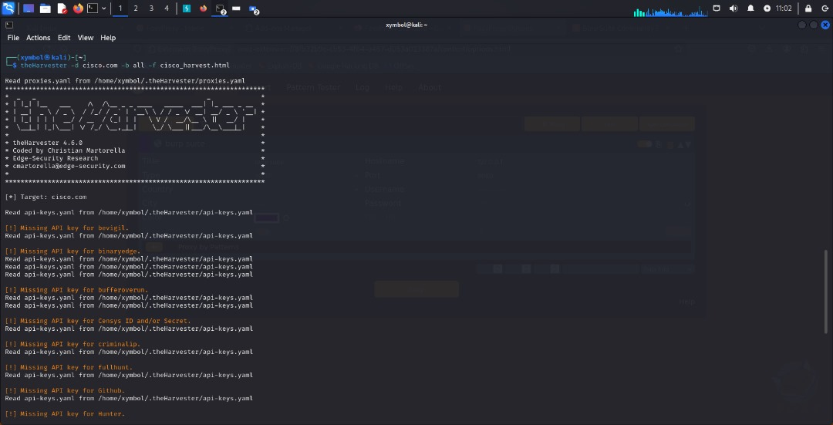

Tool Explanation – Nmap & Ping
Nmap (Network Mapper):
Nmap is a powerful open-source tool used for network discovery and security auditing. It helps identify live hosts, open ports, running services, and potential vulnerabilities. Security professionals use Nmap for reconnaissance and vulnerability assessments because it can adapt to different scanning techniques (TCP connect, SYN scan, UDP scan, etc.). In this test, Nmap was used to scan cisco.com for open ports and services. The output revealed that port 80 (HTTP) and 443 (HTTPS) are open, while other ports were filtered. This means Cisco’s public-facing servers allow web traffic only, which is a common secure configuration. However, these ports can also be exploited if misconfigured web services or SSL vulnerabilities exist.
Ping (ICMP Echo Request):
Ping is a basic but important network utility used to test connectivity between a source and a target host. It measures round-trip time (latency) and packet loss. Here, a ping test to cisco.com confirmed that the host is alive with 0% packet loss and an average latency of ~251ms. While Ping itself does not expose vulnerabilities, it is used in reconnaissance to verify target reachability and response behavior. Some organizations block ICMP responses to reduce reconnaissance exposure.

2. Results Summary
📊 Nmap Scan Results
Port | State | Service | Notes
80 | Open | HTTP | Cisco’s web server responding on port 80 (likely redirects to HTTPS).
443 | Open | HTTPS | Secure web services available; TLS/SSL must be checked for strength.
998 | Filtered | Various | Most ports are blocked by firewall or filtered.
📊 Ping Results
Metric | Value
Host Status | Alive (0% packet loss)
IP Address | 72.163.4.185
Reverse DNS | redirect-ns.cisco.com
Latency (min/avg/max) | 237ms / 251ms / 269ms
Packets Sent/Received | 4 / 4

3. Risks Identified
- Open HTTP (port 80) can expose Cisco to risks like unencrypted traffic, man-in-the-middle attacks, or redirection exploits if not properly secured.
- HTTPS (port 443), although encrypted, may contain misconfigurations (weak ciphers, outdated TLS versions, certificate issues) that attackers can exploit.
- Firewall filtering is good, but filtered ports might still leak information through banner grabbing or advanced scans.
- The fact that ICMP is enabled means Cisco is discoverable via Ping sweeps, aiding attackers during reconnaissance.
- If load balancers, reverse proxies, or CDNs are misconfigured, attackers can bypass them to reach internal systems.

4. Mitigations & Recommendations
- Ensure port 80 strictly redirects all traffic to HTTPS and does not expose sensitive content.
- On port 443, perform an SSL/TLS audit (using SSL Labs, testssl.sh, etc.) to confirm only strong ciphers and TLS 1.2+ are allowed. Disable weak protocols.
- Deploy Web Application Firewall (WAF) rules to detect and block malicious HTTP(S) traffic.
- Consider limiting or blocking ICMP Echo responses to reduce reconnaissance exposure.
- Continuously monitor logs for anomalies on these ports to detect brute-force or scanning activity.

5. Urgency & Importance
- TLS/SSL review should be conducted immediately (within 1–2 weeks) to ensure strong encryption.
- HTTP → HTTPS redirection should be enforced if not already (urgent, <1 week).
- WAF & monitoring controls should be continuously updated.
- ICMP exposure is a low-to-medium risk; mitigation can be considered within a month.

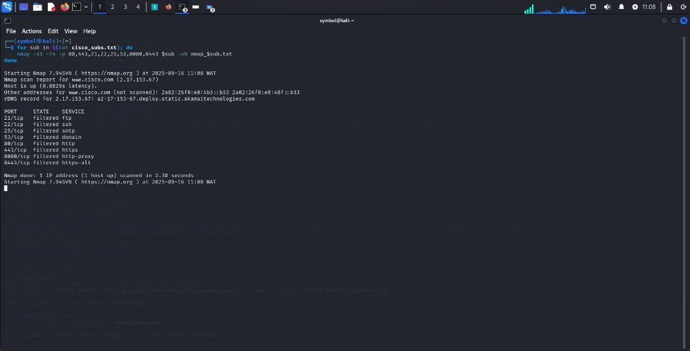
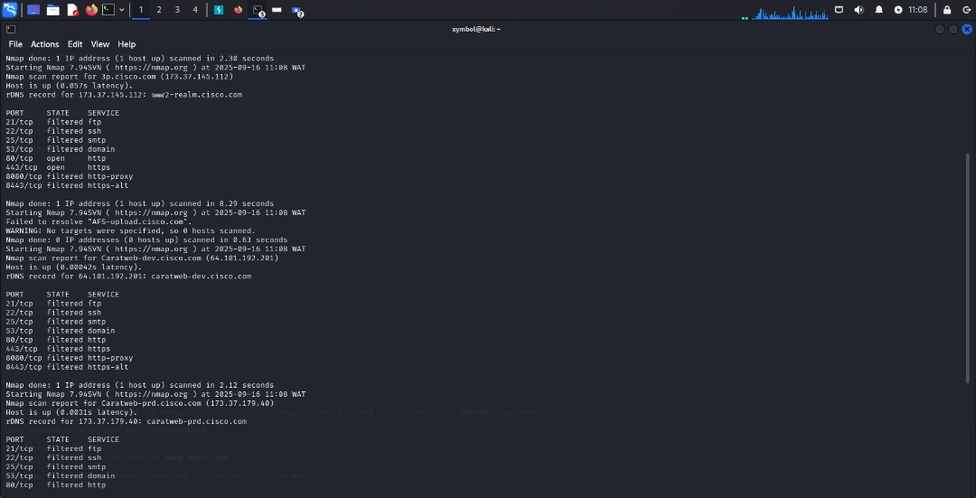
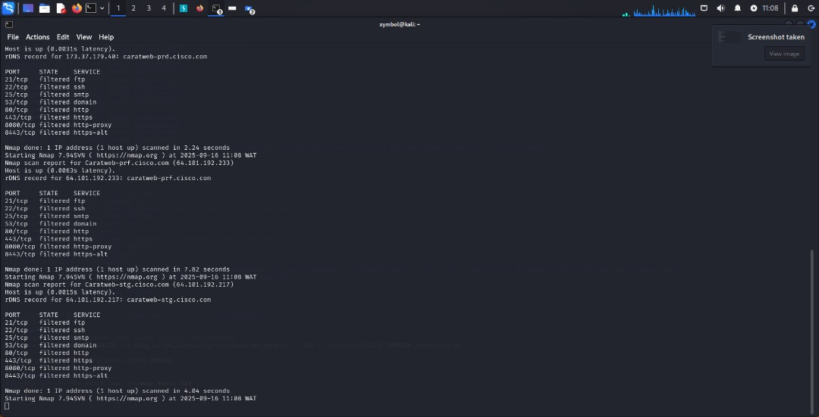
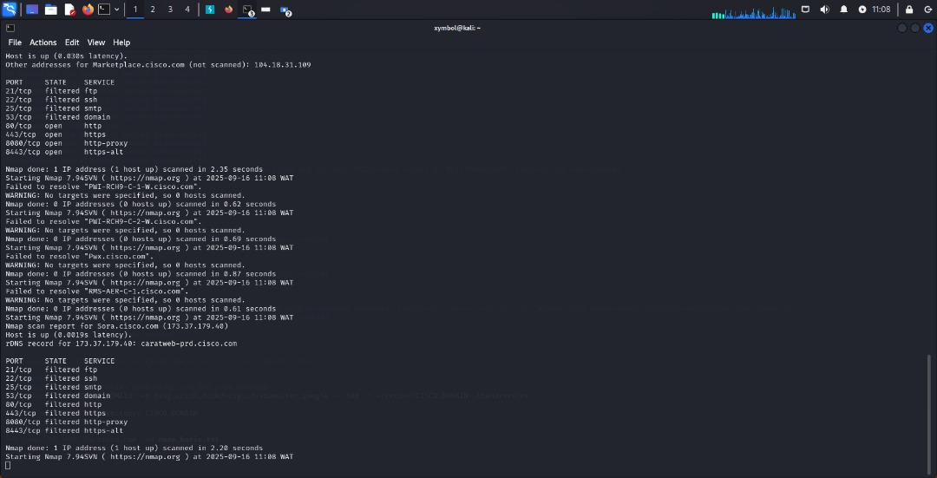
Tool Explanation – Nikto
Nikto is an open-source web server scanner designed to identify misconfigurations, outdated components, insecure cookies, missing headers, and potential vulnerabilities in web applications. It automates reconnaissance against HTTP(S) services and highlights insecure practices that attackers can exploit.
Nikto works by sending crafted requests to the web server and analyzing responses for:
- Missing or misconfigured security headers (X-Frame-Options, HSTS, X-Content-Type-Options).
- Cookies without HttpOnly or Secure flags, which may expose sensitive data.
- Outdated SSL/TLS protocols or weak ciphers.
- Default files, directories, or error pages that leak information.
- Use of Content Delivery Networks (CDNs) and reverse proxies that may affect attack surface.
Although Nikto produces many “informational” findings, these are critical for hardening web servers and preventing exploitation of web-based attacks like XSS, clickjacking, and session hijacking.

2. Results Summary
📊 Key Findings from Nikto
Finding | Risk Level | Notes
Missing X-Frame-Options header | Medium | Could allow clickjacking attacks if exploited.
Missing Strict-Transport-Security (HSTS) header | High | Makes the site vulnerable to SSL stripping and downgrade attacks.
Missing X-Content-Type-Options header | Medium | Could enable MIME-type sniffing and XSS payload execution.
Cookies (CP_GUTC, C_FPID, c_bi) created without HttpOnly flag | High | Exposes cookies to JavaScript, increasing XSS/session hijacking risk.
Cookie contains IP address (95.100.152.49) | Medium | Leaks internal/external IPs, assisting attackers in network mapping.
Server behind Fastly CDN / Akamai identified | Informational | Confirms load balancing & CDN protection in place.
Uncommon headers (x-akamai-transformed, server-timing, etc.) present | Low | Not directly exploitable but may aid in fingerprinting & targeted attacks.

3. Risks Identified
- Clickjacking Risk (X-Frame-Options missing): Attackers could embed Cisco’s site in an invisible frame and trick users into clicking malicious elements.
- SSL Stripping Risk (No HSTS): Without HSTS, attackers on public Wi-Fi can downgrade users to HTTP, intercept traffic, and perform man-in-the-middle (MITM) attacks.
- XSS & MIME Sniffing Risk (No X-Content-Type-Options): Browsers could misinterpret files, enabling XSS attacks through maliciously crafted content.
- Session Hijacking (Cookies without HttpOnly): JavaScript-accessible cookies can be stolen if XSS vulnerabilities are present.
- Information Disclosure (Cookie with IP address): Exposing IP addresses in cookies can help attackers map internal infrastructure.

4. Mitigations & Recommendations
- Implement X-Frame-Options (URGENT): Use X-Frame-Options: DENY or SAMEORIGIN to prevent clickjacking.
- Enable HSTS (High Priority, within 1 week): Add Strict-Transport-Security: max-age=31536000; includeSubDomains; preload to enforce HTTPS and block SSL downgrade attacks.
- Apply X-Content-Type-Options (Medium Priority): Set X-Content-Type-Options: nosniff to prevent MIME sniffing.
- Harden Cookie Security (High Priority): Add HttpOnly and Secure flags to all cookies. This prevents JavaScript access and ensures cookies are only transmitted over HTTPS.
- Remove IPs from Cookies (Medium Priority): Avoid embedding IPs in cookies. Replace with identifiers or hashed tokens.
- Review Uncommon Headers (Medium Priority): While not critical, unusual headers should be reviewed for sensitive data leakage.

5. Urgency & Importance
- Critical (Fix within 1 week): Missing HSTS, insecure cookies, missing X-Frame-Options.
- High Priority (Fix within 2 weeks): Add X-Content-Type-Options, remove IPs from cookies.
- Medium Priority (Fix within 1 month): Review CDN headers and uncommon response headers.

Web Application Fingerprinting (WhatWeb & Directory Enumeration)
Tool Used: WhatWeb
WhatWeb is a reconnaissance tool used to fingerprint websites by identifying technologies, frameworks, CMS versions, and security headers in use. It helps attackers and defenders understand the attack surface by revealing server details, plugins, cookies, and uncommon headers. This information is critical for vulnerability exploitation planning.
Findings:
- Server: AkamaiGHost (Akamai CDN).
- Headers: server-timing, content-security-policy.
- Cookies: CP_GUTC, C_FPID, c_bi (without HttpOnly).
- Directory enumeration attempts (with Dirbuster-style payloads) returned 403 Forbidden, including an attempt to access /etc/passwd.
Risk Explanation :
The denial of /etc/passwd attempts shows the WAF/CDN blocking malicious payloads, but repeated probing could reveal weak filtering rules. Improperly set cookies increase risks of session hijacking. Misconfigured CSP or uncommon headers may leak sensitive debugging information. Akamai CDN masks origin but attackers could attempt direct IP enumeration to bypass protections.
Recommendations (5+ lines):
- Harden WAF/CDN rules to block directory traversal and fuzzing attempts.
- Review and strengthen Content-Security-Policy (CSP) rules.
- Secure cookies with SameSite, HttpOnly, and Secure attributes.
- Perform regular penetration testing on CDN origin IPs.
- Continuously monitor headers and update them with modern security best practices.

Summary Risk Table
Tool | Findings | Risk Level | Mitigation & Recommendations
Nmap | Ports 80, 443 open | Medium | Redirect HTTP to HTTPS, patch web services, firewall rules
Nikto | Missing headers (XFO, HSTS, XCTO), insecure cookies | High | Apply security headers, set cookies with Secure/HttpOnly, enforce HSTS
WhatWeb | CDN masking, cookies, directory traversal attempts | Medium | Harden WAF/CDN rules, secure cookies, review CSP policies

✅ Importance of Recommendations & Urgency:
Cisco, being a global leader in networking and security, must fix these issues with high urgency. Missing headers and insecure cookies are often exploited in days to weeks by attackers, and since Cisco is a high-value target, threat actors may already be probing these weaknesses. Implementation should begin immediately, with patches and header enforcement rolled out within 1–2 weeks, and continuous monitoring thereafter.

ProxyChains + Nikto
ProxyChains is a tunneling tool that redirects traffic through proxy servers (SOCKS4, SOCKS5, HTTP, or Tor). It is often used by attackers to anonymize scans and bypass monitoring systems. In penetration testing, ProxyChains helps simulate stealthy attacker behavior by hiding the tester’s real IP. When combined with Nikto, it allows security assessments of web servers while masking the source.
Findings:
- Attempted Nikto scan through ProxyChains (Tor SOCKS5: 127.0.0.1:9050).
- Multiple timeout errors occurred.
- Likely causes: Cisco is blocking Tor exit nodes, or Tor service not running locally.
Risk Explanation :
The timeouts suggest Cisco’s WAF/CDN has strong filtering rules against anonymized traffic sources like Tor. This is positive from a defensive standpoint since attackers often use Tor to mask identity. However, if ProxyChains with alternative proxies (non-Tor SOCKS servers or compromised hosts) were used, attackers might still bypass monitoring. The reliance on Tor blocking alone should not be considered sufficient defense.
Recommendations :
- Continue blocking known Tor exit nodes and anonymizer IPs.
- Implement GeoIP filtering for unnecessary regions.
- Deploy rate limiting and anomaly detection for traffic spikes, regardless of origin.
- Enforce WAF rules that block suspicious patterns (payloads, fuzzing, unusual headers).
- Monitor SIEM logs for repeated proxy/anonymizer attempts and automatically blacklist IPs.
⚡ Urgency:
The defensive configuration is good (Tor blocked), but reliance on Tor blacklisting alone is
not enough. Cisco should implement advanced traffic anomaly detection immediately (1–2 weeks), ensuring non-Tor proxies and residential IP-based attacks are also identified

WAF Detection (WAFW00F Results)
Tool Used: WAFW00F (Web Application Firewall Fingerprinting Toolkit)
WAFW00F is a powerful reconnaissance tool used to identify the presence and type of Web Application Firewall (WAF) protecting a website. Its functionality helps penetration testers understand how traffic is being filtered, blocked, or monitored.
- WAFW00F fingerprints web defenses by sending crafted requests and analyzing the responses.
- It detects whether a site is using a WAF, intrusion detection (IDS), or intrusion prevention system (IPS).
- Identifies specific vendors such as Akamai, Cloudflare, F5, Imperva, etc.
- Provides insights into the rulesets and filtering behaviors by analyzing HTTP error codes like 403, 404, 405, and 500.
- Allows testers to know whether evasion techniques (e.g., encoding payloads, header manipulation) may be required.
- Assists in determining whether fuzzing or automated scanning will be blocked or flagged.
- Helps organizations validate that their WAF solution is properly deployed and actively filtering malicious traffic.
- Provides visibility into layered defenses so security engineers can strengthen detection rules.
- Informs red teams that additional stealth and proxy usage will be required to bypass detection.
- For large enterprises like Cisco, WAF detection is crucial because it confirms perimeter web security enforcement.

Findings (Summary Table)
Target | WAF Detected | Provider | Notes
https://www.cisco.com | Kona SiteDefender | Akamai | WAF actively filtering requests, returned 403/405/500 responses

Risks Identified
- False Sense of Security: While WAF provides strong protection, attackers may still bypass it using advanced evasion (obfuscation, fragmentation, encoding).
- Target for Evasion Attempts: Cisco’s reliance on Akamai Kona means attackers may focus efforts on identifying bypass techniques specific to Akamai rulesets.
- Potential Gaps in WAF Rules: If not regularly updated, the WAF may fail to block zero-day exploits or sophisticated attack payloads.
- Performance Dependency: Heavy reliance on a third-party WAF provider means outages or misconfigurations at Akamai could affect Cisco services.
- Insider or Misconfigured Rules Risk: If administrators whitelist unsafe IPs or fail to enforce strict rules, malicious traffic may still pass through.

Recommendations & Mitigations
- Regular WAF Rule Updates: Ensure Akamai Kona’s signature sets and behavioral rules are updated frequently to protect against zero-day exploits.
- Enable Advanced Detection Modes: Use anomaly detection, machine learning, and behavior-based filtering beyond simple signature matching.
- Conduct WAF Penetration Testing: Regularly simulate bypass attempts (e.g., encoding payloads, parameter pollution) to confirm effectiveness.
- Implement Multi-Layer Security: Do not rely solely on WAF — ensure strong patch management, server hardening, and secure coding practices.
- Monitor and Log WAF Events: Integrate WAF logs into Cisco’s SIEM for real-time alerting, threat correlation, and incident response readiness.

Importance of Recommendations
- Urgency: High — WAF bypass techniques evolve quickly; updating and testing rules should be ongoing, monthly at minimum.
- Impact: Reduces the risk of successful exploitation of Cisco’s web-facing infrastructure.
- Operational Benefit: Ensures WAF is not just a "compliance checkbox" but an active defense mechanism.
- Long-Term Value: Strengthens Cisco’s layered defense strategy and ensures resilience against advanced persistent threats (APTs).

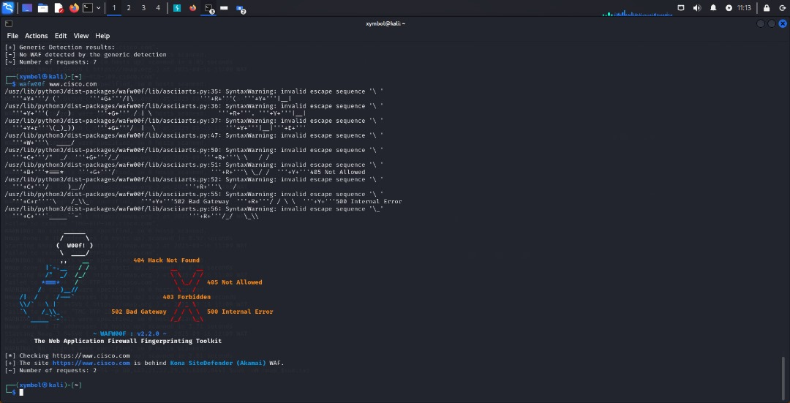

OWASP ZAP (Zed Attack Proxy)
OWASP ZAP is a widely used open-source security tool for penetration testing web applications. It operates as a proxy between the client and the server and allows testers to intercept, inspect, and modify traffic.
ZAP supports both manual testing and automated scanning of web applications. It is effective at identifying issues like:
- Cross-Site Scripting (XSS).
- SQL Injection.
- Information Disclosure.
- Misconfigured Security Headers.
- Insecure Cross-Domain Requests.
- Authentication/Session flaws.
It has modules such as Spider, AJAX Spider, Active Scanner, Passive Scanner, and Fuzzer that provide deep inspection of a target. In this case, ZAP flagged Cross-Domain JavaScript Inclusion, which means external JavaScript is being loaded from a third-party domain. This is critical because if the external source is compromised, malicious code could be injected into Cisco’s application.

🔹 Vulnerability: Cross-Domain JavaScript Source File Inclusion
Description:
The web page loads JavaScript from a third-party domain. This creates a potential supply-chain attack risk because the code is outside Cisco’s direct control.

🔹 Risk Explanation :
- Attackers could compromise the third-party domain and inject malicious JavaScript into Cisco’s site.
- Users interacting with the compromised script could have credentials stolen, sessions hijacked, or malware delivered.
- It may lead to defacement, phishing attacks, or redirection to malicious websites.
- Sensitive Cisco customer or employee data processed on affected pages could be exfiltrated without detection.
- The risk expands Cisco’s attack surface, making it dependent on external security policies and uptime.

🔹 Mitigation & Recommendations
- Only include JavaScript from trusted, verified, and whitelisted sources under Cisco’s control.
- Implement Subresource Integrity (SRI) checks for all external scripts. This ensures tampering is detected before execution.
- Where possible, self-host all scripts instead of relying on external CDNs.
- Apply a strict Content Security Policy (CSP) to limit which domains are allowed to serve scripts.
- Regularly monitor included scripts for changes, vulnerabilities, or malicious code injection attempts.

🔹 Importance & Urgency of Recommendation
- Importance: This is a supply chain risk, which has been the root cause of major breaches (e.g., SolarWinds, Magecart). For a large company like Cisco, reputation and trust are critical.
- Urgency: Fix should be treated as High Priority. Immediate mitigation (via CSP + SRI) should be applied while long-term solutions like self-hosting scripts are implemented.

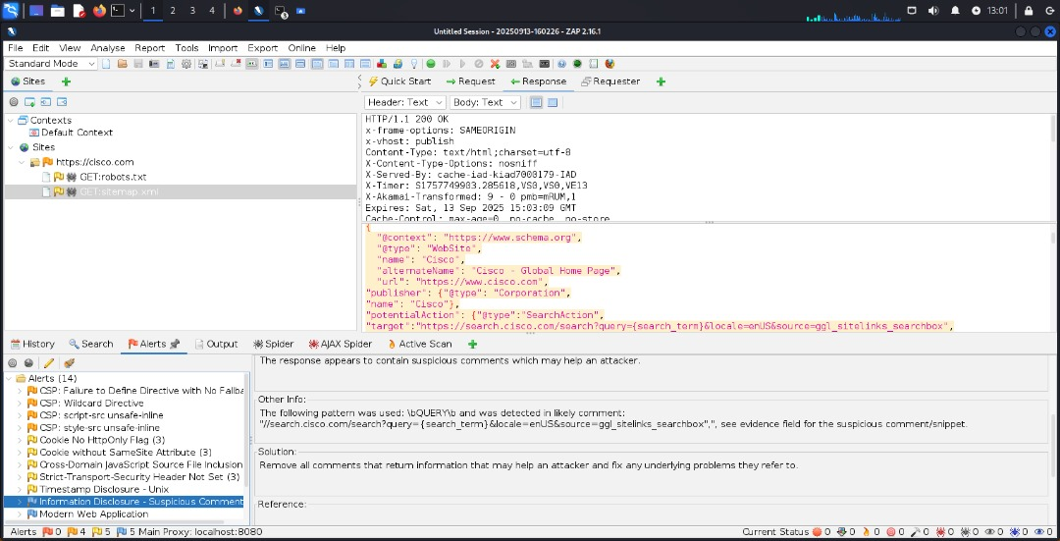
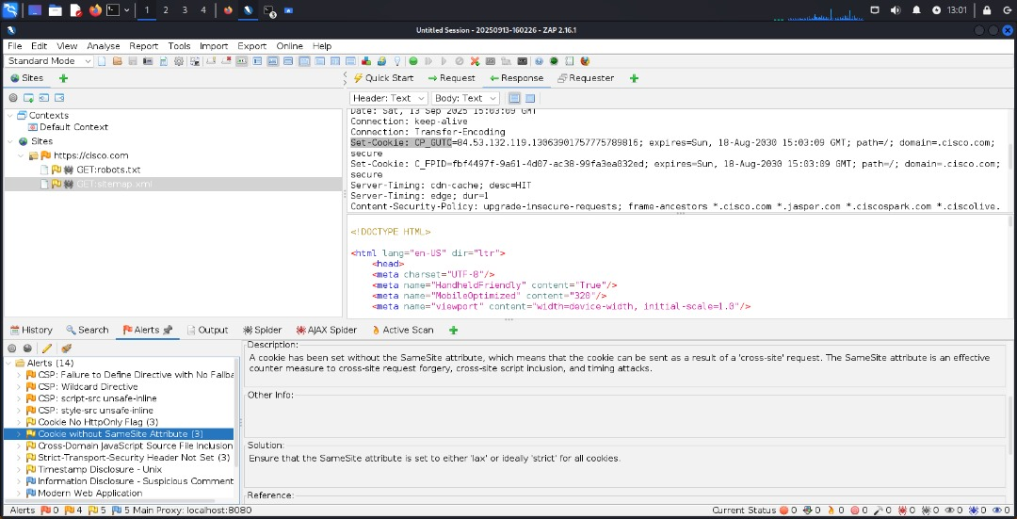
🔹 Table Summary
Vulnerability | Tool Used | Risk | Mitigation Priority | Recommendation
Cross-Domain JavaScript Source File Inclusion | OWASP ZAP | High | Immediate | Enforce CSP, SRI, and self-host trusted scripts
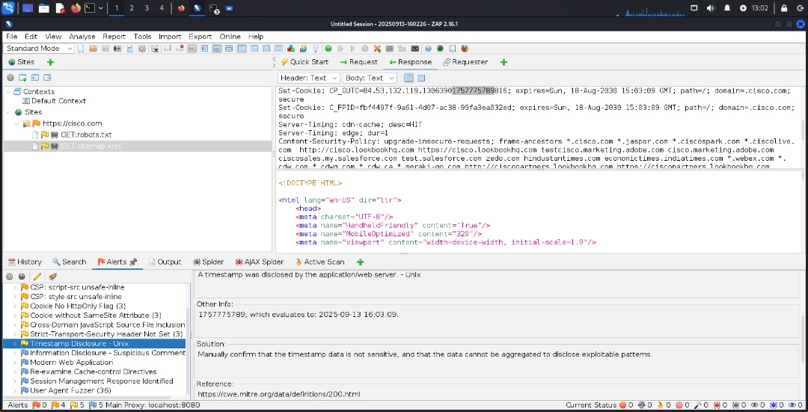

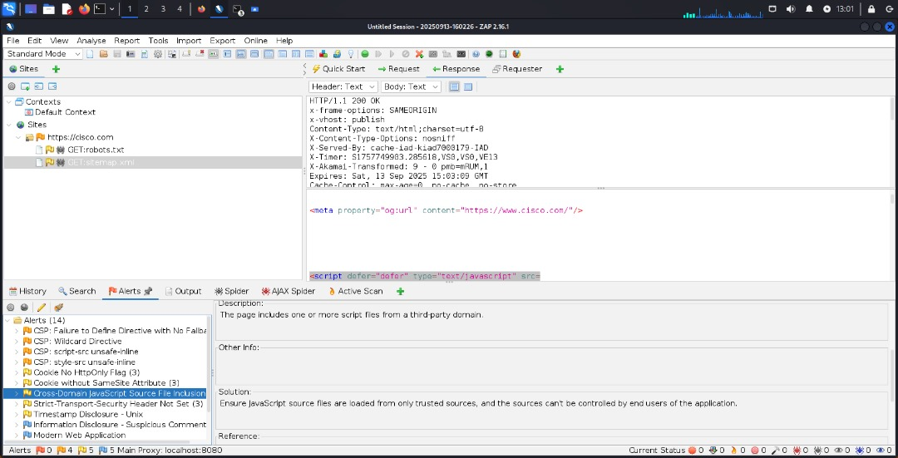

Appendix

A. Evidence Files (collected)

All files were produced in the working directory (e.g., ~/pentest_www.cisco.com). Attach these to the report package:

- subfinder.txt
- amass_passive.txt
- subdomains_all.txt
- subdomains_live.txt
- wafw00f_www.txt
- whatweb_www.txt
- masscan_72.163.4.185.txt
- masscan_results.txt
- nmap_72.163.4.185.txt
- nmap_www.txt
- ssl_enum_www.txt
- cert_www.txt
- headers_full_www.txt
- gobuster_www.txt
- dirsearch_www.txt
- ffuf_www.json
- nuclei_takeover.txt
- nuclei_cves.txt
- nikto_www.txt
- wapiti_www.txt
- subjack.txt

References & Tool links (append to report)

Use these references for tool documentation and methodology background:
- theHarvester — https://github.com/laramies/theHarvester
- Subfinder — https://github.com/projectdiscovery/subfinder
- Amass — https://github.com/OWASP/Amass
- httpx — https://github.com/projectdiscovery/httpx
- masscan — https://github.com/robertdavidgraham/masscan
- nmap — https://nmap.org/
- WhatWeb — https://github.com/urbanadventurer/WhatWeb
- WafW00f — https://github.com/EnableSecurity/wafw00f
- Gobuster — https://github.com/OJ/gobuster
- Dirsearch — https://github.com/maurosoria/dirsearch
- FFUF — https://github.com/ffuf/ffuf
- Nikto — https://github.com/sullo/nikto
- Wapiti — https://github.com/wapiti-scanner/wapiti
- Nuclei — https://github.com/projectdiscovery/nuclei
- Subjack — https://github.com/haccer/subjack
- Hydra — https://github.com/vanhauser-thc/thc-hydra
- Burp Suite (PortSwigger) — https://portswigger.net/burp
- OWASP ZAP — https://www.zaproxy.org/
- Shodan — https://www.shodan.io/
- Censys — https://censys.io/
- SecurityTrails — https://securitytrails.com/

Findings (summary)

- CDN/WAF: www.cisco.com is fronted by Akamai (Kona SiteDefender) — evidenced by CNAME chain, Akamai edge IPs, Server-Timing: ak_p, and X-Served-By headers. (See headers_full_www.txt, whatweb_www.txt.)
- Open services at edge: Only HTTP (80) and HTTPS (443) detected; other ports appear filtered. (See nmap_*, masscan_*.)
- Directory enumeration: Numerous protected paths returned 403 (e.g., _db_backups, _config, .ht* backup filenames). These are blocked but indicate potential places to monitor for accidental exposure. (See dirsearch_www.txt, ffuf_www.json.)
- CSP & partner domains: CSP allowed origins include many partner/3rd-party domains (Salesforce, Webex, Duo, Umbrella, Vercel, Mapbox, cdnjs.cloudflare.com, etc.). These increase the attack surface and should be reviewed for misconfigurations/takeover risk. (See headers_full_www.txt.)
- Automated vulns: No high-confidence critical vulnerabilities were discovered by the automated scans run. Manual, authenticated testing is recommended for application logic issues and deeper validation.

F. Recommendations
- Focus further testing on in-scope, application-level endpoints (use Burp Pro for controlled active tests).
- Review & monitor the CSP partner list for third-party misconfigurations and domain takeovers.
- Ensure backup/config files are not present in public web roots anywhere in the estate.
- Maintain Akamai/WAF rules and coordinate any aggressive scanning with the client (rate limits, maintenance windows).
- Schedule periodic automated scans and keep nuclei templates and scanners up-to-date.

